33.60: a) To let the most light possible through N polarizers, with a total rotation of 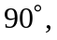 we need as little shift from one polarizer to the next. That is, the angle between successive polarizers should be constant and equal to 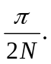 Then:
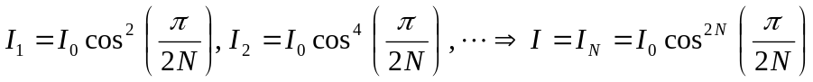.
b) If 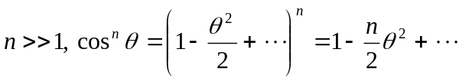
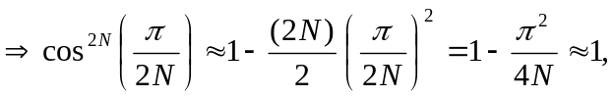 for large N.

